ThIn-ventory Installation and

Configuration guide

Version 1.0

Table of Contents
Overview 3
Supported Hardware 3
Installation Overview 4
Installation Steps 5
iSeries Installation 5
License Key Installation 5
Handheld Device Client Installation 6
Client Configuration 7
Admin Tool Install 8
Configuring the ThIn-ventory Server 9
iSeries 9
GUI Admin Tool 11
Set the server IP Address and Port Number 11
Administering Devices 12
Starting and Stopping the Server 12
Troubleshooting / FAQ’s 13

Overview

ThIn-ventory is a customizable handheld device solution that allows a user to process iSeries Paper-Less transactions anywhere, anytime. This document outlines the steps necessary to install and configure the ThIn-ventory Server and Client.

If you are in need of assistance, contact the Paper-Less Help Desk at 1-888-473-0800 or email at Help.Desk@paperlessllc.com.

Supported Hardware

ThIn-ventory uses a third-part scripting engine called NS Basic/CE (www.nsbasic.com/ce). This scripting engine determines what version(s) of Microsoft’s Mobile Device Operating Systems ThIn-ventory supports.

NS Basic/CE supports the following Microsoft Mobile Operating Systems
- Windows Mobile up to 6.5
  - This includes Windows Mobile 2003, 5, 6, 6.1, and 6.5.
- Pocket PC
- Windows CE
  - 5.0
  - 4.2

ThIn-ventory is known to work on the following hardware
- Intermec
  - 700 Series, which includes 700C, 750, and 751
  - CK31
  - CK61
  - CN3
  - CN70
- Symbol/Motorola
  - MC9000 series

Installation Overview

There are two main technology platforms used to present ThIn-ventory, the iSeries and the mobile device running a Windows operating system.

The iSeries is used to execute the existing applications, which will perform the necessary logic and editing to process the transaction(s). The iSeries is also the repository for storing the screen designs and logic scripts which will be executed on the mobile device

The mobile device is responsible for displaying the screens and returning values to the iSeries.

What is needed:
- Installation CD
  - This contains the iSeries and Client install files
- Desktop PC with the ability to connect to the device cradle using ActiveSync (Windows XP) or Windows Mobile Device Center (WMDC on Windows 7)
- A Mobile Device with wireless connectivity to your iSeries
- License key (Printed document containing your license key which is e-mailed to you from the Paper-Less Help Desk).
  - If you are in need of a license key, contact the Help Desk at 1-888-473-0800 or email at Help.Desk@paperlessllc.com
  - You will need to provide your iSeries Serial Number to the Help Desk for the license key

Installation Steps

Below are the necessary steps for installing ThIn-ventory:

iSeries Installation

- Click here to launch the iSeries installation program
- The link will launch the D:\ThinAppS AS400 Installer\ThinAppSAS400Installer.exe application
- You will need to be on a workstation that has access to the iSeries with TCP/IP
- The system will reboot after the initial setup is run to install the necessary ODBC drivers.
- After the system reboots, click on the windows Start task bar, select Programs and from the Programs menu click on ThinApps -> ThinAppS AS400 Installer.
- A welcome screen will display, Press OK to continue.
- Fill in the screen shown below:

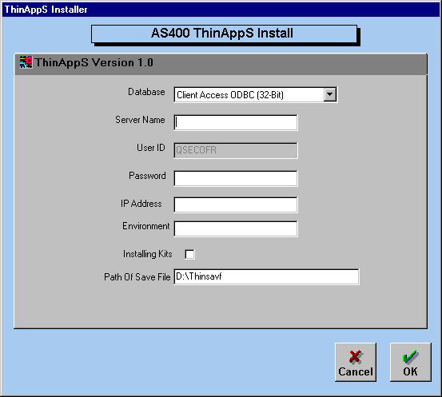
- Server Name: Name of your iSeries
- Password: Password of your QSECOFR profile
- IP Address: IP address of your iSeries
- Environment: ThinAppS environment designator. (2 character designator)
- Installing kits: This box MUST be checked.
- Path Of Save File: Path of the installation cd. This path should be automatically defaulted.

Once OK is pressed, the installation procedure will inform you as to its progress. If the install encounters an error condition, the window display will inform you what action to take.

In the event that you receive an error message do the following:
- Log the error message displayed
- Contact the Help Desk at 1-888-473-0800 or email at Help.Desk@paperlessllc.com

License Key Installation

Have a printed copy of the <iSeries Serial Number>.txt document you received via e-mail from the Help Desk.

To apply the License Key
- Enter the following command to get the Work with Licenses screen.
  - WRKLICINF
  - F4 to prompt
  - Product identifier = 1THINAP
  - Press Enter
- Add the license key
  - Enter Option 1 on Feature 5105 – ThinAppS
  - Enter the License Key characters
  - Enter the License Key Usage limit
  - Enter the License Key Expiration Date
  - Press Enter
    - You should receive a message stating “1 license key information records added to repository.”

Handheld Device Client Installation

There is only one executable to run to install the ThIn-ventory Client to the device however this requires the device to be connected to a PC.

Windows XP uses Microsoft ActiveSync to communicate with handheld devices. Windows 7 uses Windows Mobile Device Center (WMDC).

Once the Device is connected to the PC, run the ThIn-ventory Client installer from <CD Drive>:\Client\ThIn-ventory Client.exe. This will install both the NS Basic/CE Scripting Engine and the ThIn-ventory Client to the Handheld Device.

Client Configuration

The Owner information file is used by the ThIn-ventory Client on the Handheld Device to identify itself to the iSeries.

To launch the Owner Maintenance program, tap the 'OwnerMaint' icon under Programs. Below is a screenshot as you will see it on the device.

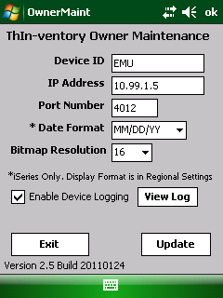

Fill in the information as described below and when complete, tap the Update button.
- Device ID: The unique name of the Device. This name must be setup in the ThIn-ventory Server on the iSeries.
- IP Address: The IP Address of your iSeries
- Port: The Port Number linked to the desired Paper-Less environment on the iSeries
  - Note: The devices don’t connect to environment’s, they connect to Port’s which are setup in the ThIn-ventory Server to represent Paper-Less environments
- Date Format: The date format used on the iSeries
  - The Date Format of the device is controlled by Regional Settings
- Image Bitmap: Specifies the resolution of the bitmap images to display on the Device.
- Enable Device Logging: Configure the Device to create a log file at \Program Files\ThIn-ventory\logs\thinlog.txt that contains the Client->Server communication output.

Admin Tool Install

This tool allows you to administer the ThIn-ventory Server from a PC.

Click here to launch the Admin Tool installation program. A shortcut will be created in your Programs folder.

Configuring the ThIn-ventory Server

There are two options for configuring the ThIn-ventory server. The first option is through the PC based Admin Tool and the other is through the ThIn-ventory Green Screen menu on the iSeries.

iSeries

This section walks through the configuration of the ThIn-ventory Server using the iSeries configuration menu.

Launching the Configuration Menu
- From the command line, enter “THIN” and press Enter

- Select the environment and press Enter

- This will display the ‘Main Menu’. Generally the only option used is #3 – Handheld Device Support Menu
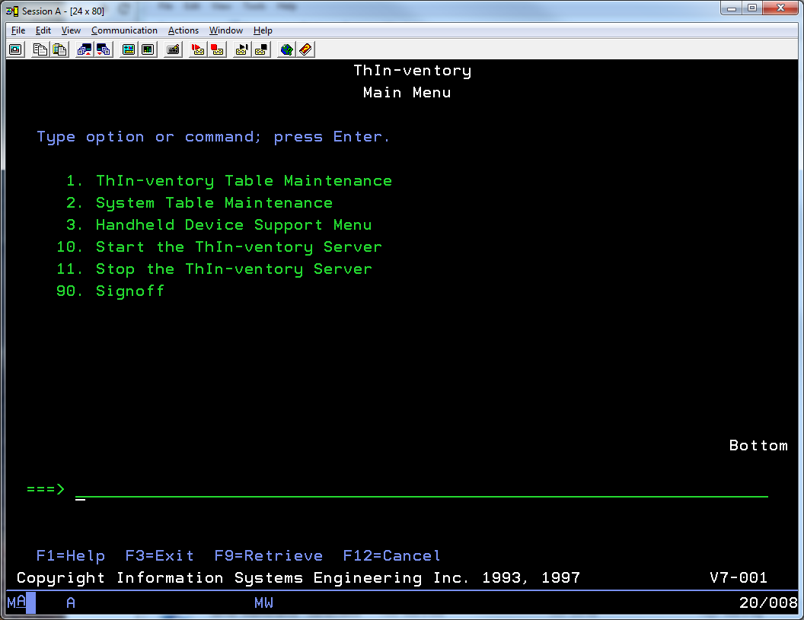

- Select Option #3 – Handheld Device Support Menu. This will display the following screen
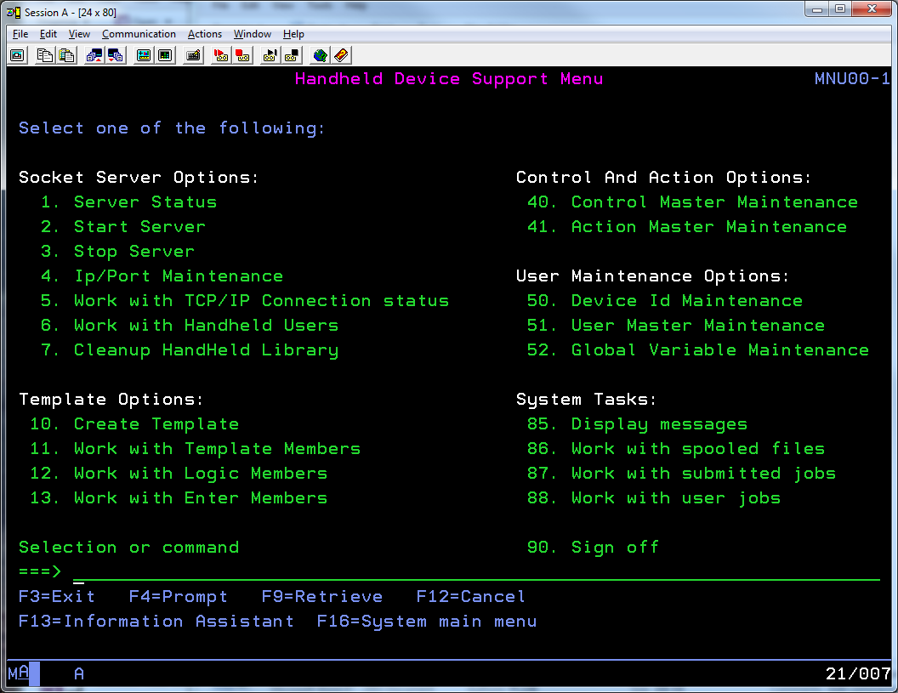

The most frequently used options are:
- 1 – Server Status
  - This will display a message at the bottom of the screen stating the Server is Started or Stopped
- 2 – Start Server
  - Start the Server
- 3 – Stop Server
  - Stop the Server
- 4 – IP/Port Maintenance
  - Configure the Server specifying the IP Address of the iSeries and what Port number to listen on.
- 6 – Work with Handheld Users
  - Display a list of the Handheld Devices, showing which are currently connected and the job details
- 50 – Device Id Maintenance
  - Add/Modify/Delete Device Id’s
  - Use this when adding/removing a device
  - Each Device must have a unique Id
- When adding a new device using the F6-Create option
  - The ID and Owner fields should be the same value
  - The User Name should be ISEKIT
  - Example: To add a new device named DEVICE5:
    - ID = DEVICE5
    - Owner = DEVICE5
    - User Name = ISEKIT
    - Type = blank
    - IP Address = blank
- 52 – Global Variable Maintenance
  - Used to set the Global Variables each Device should use
- Examples are the iSeries Username (&USERID) and Password (&PASSWORD) to use when processing transactions. *Note: These are defaulted to ISEKIT/ISEKIT at install.

GUI Admin Tool

This section walks through the configuration of the ThIn-ventory Server using the Windows GUI Admin Tool.

Launch the Admin Tool from Start -> Programs menu.

The ‘Client Tailoring Options’ window is displayed

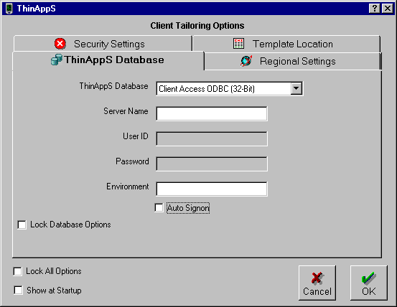

Select the database type and fill in the values for the system name and environment. The Show at startup option, if checked, will show this window every time the application starts. This allows the user to change the database parameters before signing on. Lock Database Options will prevent any user from changing the database parameters once the OK button is pressed. It will also override the Show at startup option. If you want the program to log onto the iSeries using a set user ID and password then check the Auto Signon box and fill in the values for User ID and Password.
- Server Name: The name of your iSeries
- User Id: The iSeries Userid
  - During installation, the Userid THINAPP<XX> is created and it is recommended this profile is used here. The <XX> is the environment where ThIn-ventory was installed
- Password: The password for the iSeries Userid.
  - For the THINAPP<XX> Userid, the Password is also THINAPP<XX>
- Environment: The two character Environment where ThIn-ventory is installed

Set the server IP Address and Port Number

The ThinAppS server program needs to know the IP address and the Port number of your iSeries where the server program is running.

- Select the Server Tab in the Admin Tool.
- Right-click within the white box and a popup menu will display showing the available options.
- Select IP Port Maintenance. Fill in the IP address and port number and press Ok.
  - The IP Address is that of the iSeries
  - The Port Number must be unique to each Environment. Typically start with 4000 and increment by 5 for additional environments such as a Test environment.

Administering Devices

Each Device must be defined, uniquely, in the ThIn-ventory Server.

- Select the Server Tab in the Admin Tool.
- Right-click within the white box and a popup menu will display showing the available options.
- Select Device Options -> Add, Change or Delete Device
  - Device Id: A Unique name
  - Device Owner: The same name as the Device Id
  - Device User: Select ‘ISEKIT’
  - Device IP Address: Leave blank
  - Desktop Version: Leave unchecked
- Click Insert, Update or Delete
- Click Cancel to return to the Application

You also have the option of double-clicking on an existing device to maintain it.

Starting and Stopping the Server

The ThIn-ventory Server must be started to accept incoming connections from the Handheld devices.

To Start/Stop the server, click the ‘Start Server’ or ‘Stop Server’ button in the upper left corner of the Admin Tool.

Troubleshooting / FAQ’s

- If using PLMC/MDCC as the Data Collection System, the following Tailoring questions must be answered as follows:
  - PLMC Table Maintenance
  - Table “10”
    - Question #47 must be answered “N”
    - Question #48 must be answered “N”

- If using PBLSi (Paper-Less Barcode Labeling Software for the iSeries), Runtime Prompting must be turned off for the transactions processed through ThIn-ventory
  - Start PLMC
  - Enter CFGLBL on the command line and press Enter
  - Option 2 (Transaction Settings)
  - Option 2 (Edit) on the Transaction(s)
  - Interface/Mode can’t be “S”

- The application on the device starts and the message “Unable to connect to the server” or a blank grey screen is displayed
  - This means that either the device is not (properly) connected to the wireless network or the ThIn-ventory Server is not running.

- Receiving “Enter Reqd Fields”, “Invalid Order” when entering a Turnaround Number, or “Invalid Turnaround” when entering an Order Number.
  - Check the PLMC / MDCC Tailoring options. See the first bullet on this page.

- Starting and Stopping the ThIn-ventory Server from a job scheduler
  - Start
    - THIN ENV(<xx>) MENUID(MM) MENUOPT(10) EXIT(Y)
    - Replace <xx> with your environment designator
  - Stopping
    - THIN ENV(<xx>) MENUID(MM) MENUOPT(11) EXIT(Y)
    - Replace <xx> with your environment designator

